easy

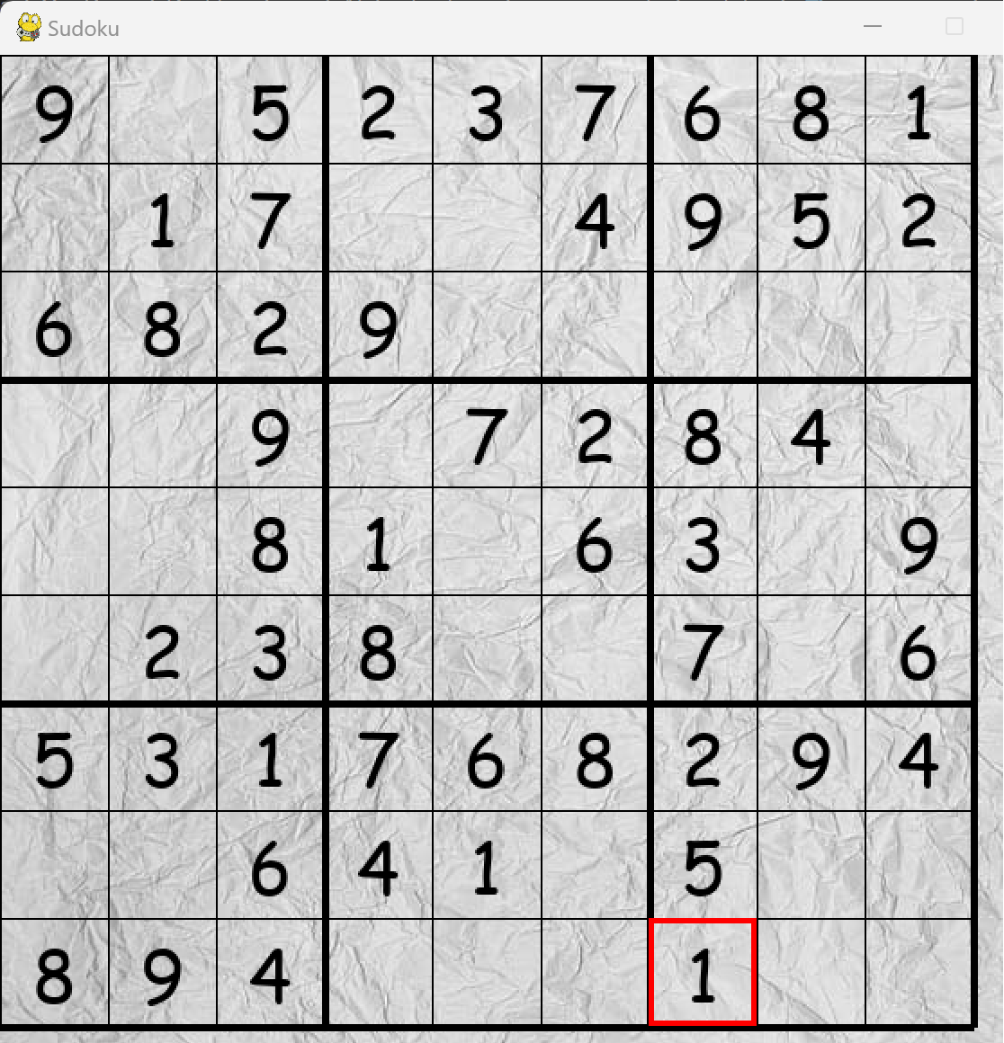



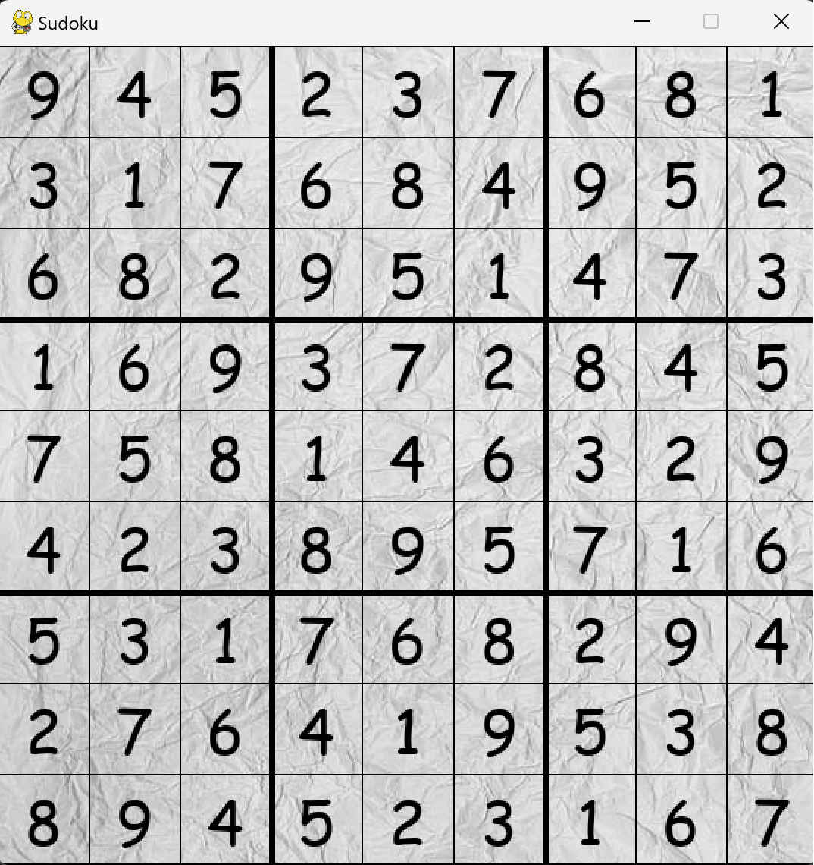

--arc consistent added 4 to pos1

----arc consistent added 3 to pos9

------arc consistent added 6 to pos12

--------arc consistent added 8 to pos13

----------arc consistent added 5 to pos22

------------arc consistent added 1 to pos23

--------------arc consistent added 4 to pos24

----------------arc consistent added 7 to pos25

------------------arc consistent added 3 to pos26

--------------------arc consistent added 1 to pos27

----------------------arc consistent added 6 to pos28

------------------------arc consistent added 3 to pos30

--------------------------arc consistent added 5 to pos35

----------------------------arc consistent added 7 to pos36

------------------------------arc consistent added 5 to pos37

--------------------------------arc consistent added 4 to pos40

----------------------------------arc consistent added 2 to pos43

------------------------------------arc consistent added 4 to pos45

--------------------------------------arc consistent added 9 to pos49

----------------------------------------arc consistent added 5 to pos50

------------------------------------------arc consistent added 1 to pos52

--------------------------------------------arc consistent added 2 to pos63

----------------------------------------------arc consistent added 7 to pos64

------------------------------------------------arc consistent added 9 to pos68

--------------------------------------------------arc consistent added 3 to pos70

----------------------------------------------------arc consistent added 8 to pos71

------------------------------------------------------arc consistent added 5 to pos75

--------------------------------------------------------arc consistent added 2 to pos76

----------------------------------------------------------arc consistent added 3 to pos77

------------------------------------------------------------arc consistent added 6 to pos79

--------------------------------------------------------------arc consistent added 7 to pos80

Intermediate:

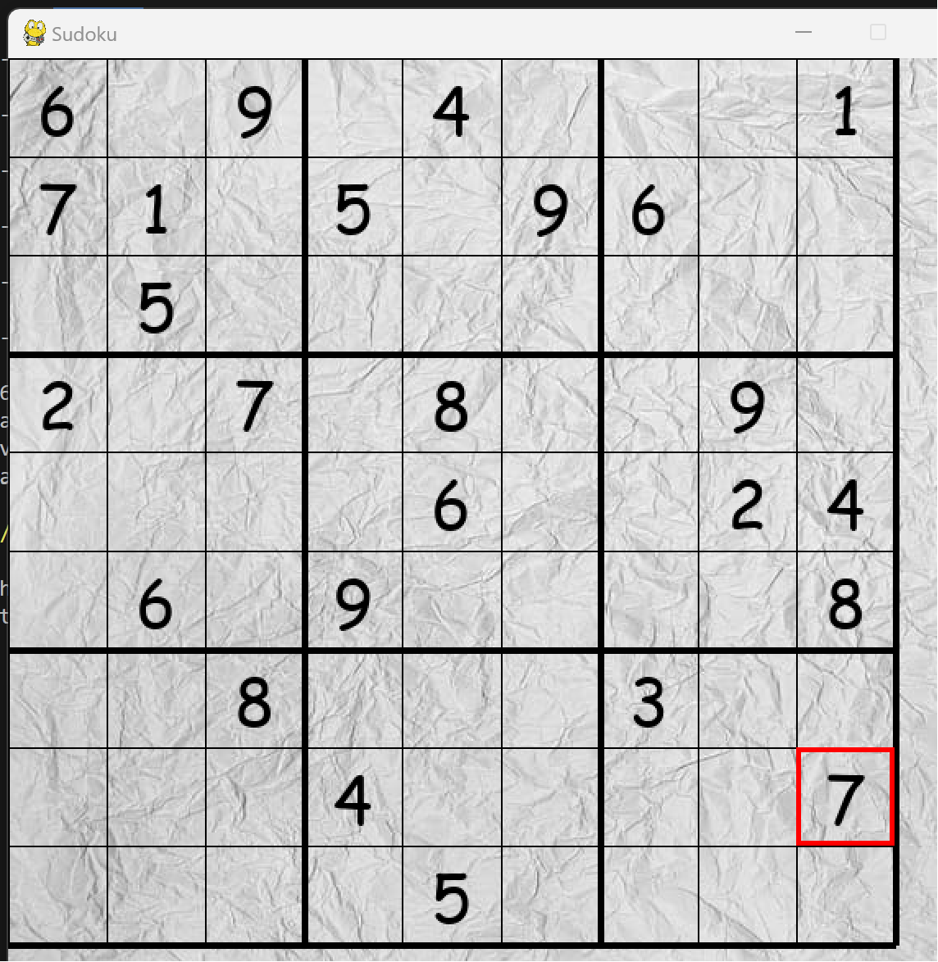



Part of search tree

--not arc consistent removed 9 from pos58

--not arc consistent removed 6 from pos57

----arc consistent added 2 to pos57

------arc consistent added 9 to pos58

--------arc consistent added 6 to pos59

----------arc consistent added 4 to pos61

------------arc consistent added 5 to pos62

--------------arc consistent added 5 to pos63

----------------arc consistent added 3 to pos67

------------------arc consistent added 6 to pos70

--------------------arc consistent added 9 to pos72

----------------------arc consistent added 1 to pos79

------------------------arc consistent added 4 to pos24

--------------------------arc consistent added 8 to pos36

not arc consistent removed 8 from pos36

not arc consistent removed 4 from pos24

not arc consistent removed 1 from pos79

not arc consistent removed 9 from pos72

not arc consistent removed 6 from pos70

--arc consistent added 1 to pos70

----arc consistent added 9 to pos72

------arc consistent added 6 to pos79

--------arc consistent added 4 to pos24

----------arc consistent added 8 to pos36

------------arc consistent added 6 to pos65

--------------arc consistent added 8 to pos68

----------------arc consistent added 9 to pos69

------------------arc consistent added 4 to pos73

--------------------arc consistent added 3 to pos74

----------------------arc consistent added 8 to pos78

------------------------arc consistent added 6 to pos21

not arc consistent removed 6 from pos21

--arc consistent added 8 to pos21

--not arc consistent removed 8 from pos21

--not arc consistent removed 8 from pos78

--not arc consistent removed 3 from pos74

--not arc consistent removed 4 from pos73

--not arc consistent removed 9 from pos69

--not arc consistent removed 8 from pos68

--not arc consistent removed 6 from pos65

--not arc consistent removed 8 from pos36

--not arc consistent removed 4 from pos24

--not arc consistent removed 6 from pos79

--not arc consistent removed 9 from pos72

--not arc consistent removed 1 from pos70

--not arc consistent removed 3 from pos67

--not arc consistent removed 5 from pos63

----arc consistent added 9 to pos63

------arc consistent added 3 to pos67

--------arc consistent added 6 to pos70

not arc consistent removed 6 from pos70

--arc consistent added 1 to pos70

--not arc consistent removed 1 from pos70

--not arc consistent removed 3 from pos67

--not arc consistent removed 9 from pos63

--not arc consistent removed 5 from pos62

--not arc consistent removed 4 from pos61

--not arc consistent removed 6 from pos59

--not arc consistent removed 9 from pos58

--not arc consistent removed 2 from pos57

--not arc consistent removed 7 from pos55

----arc consistent added 4 to pos55

------arc consistent added 6 to pos57

--------arc consistent added 9 to pos58

----------arc consistent added 7 to pos59

not arc consistent removed 7 from pos59

--arc consistent added 2 to pos59

--not arc consistent removed 2 from pos59

--not arc consistent removed 9 from pos58

--not arc consistent removed 6 from pos57

----arc consistent added 2 to pos57

------arc consistent added 9 to pos58

--------arc consistent added 6 to pos59

not arc consistent removed 6 from pos59

--arc consistent added 7 to pos59

----arc consistent added 6 to pos61

------arc consistent added 5 to pos62

--------arc consistent added 5 to pos63

----------arc consistent added 3 to pos67

------------arc consistent added 1 to pos70

--------------arc consistent added 9 to pos72

----------------arc consistent added 4 to pos79

------------------arc consistent added 4 to pos24

--------------------arc consistent added 8 to pos36

----------------------arc consistent added 6 to pos65

------------------------arc consistent added 8 to pos68

--------------------------arc consistent added 9 to pos69

----------------------------arc consistent added 7 to pos73

------------------------------arc consistent added 3 to pos74

--------------------------------arc consistent added 8 to pos78

----------------------------------arc consistent added 6 to pos21

not arc consistent removed 6 from pos21

--arc consistent added 8 to pos21

----arc consistent added 6 to pos23

------arc consistent added 2 to pos50

--------arc consistent added 6 to pos75

----------arc consistent added 1 to pos77